Employee Self Service (ESS)
User Manual

Contents
INTRODUCTION 4
Purpose of the document 4
How to Use the User Manual 4
Glossary 4
Human Capital Management (HCM) Overview 6
Overview of Employee Self Services 7
Road Map 8
Employee Self Services – Scenarios 9
Logging on to SAP EP System 13
Understanding elements of SAP EP (Portal Desktop) 15
Navigating Menus 15
Logging out of SAP EP System 17
Scenario: Employee Search 18
Introduction 18
Scenario Diagram 19
Who’s Who 19
Change own data 22
Scenario: Personal Information 26
Introduction 26
Scenario Diagram 27
Address 28
Bank Information 34
Family Member /Dependents 38
Personal Data 43
Immovable Property Returns 49
Scenario: Working Time 54
Introduction 54
Leave Request 56
Quota Overview 61
Joining Reports 63
Scenario: Career and Jobs 66
Introduction 66
Scenario: Travel and Expenses 77
Introduction 77
My Trip and Expenses 78

INTRODUCTION

Purpose of the document
The purpose of the training guide is to provide documentation on how to use the SAP Employee Self Service system that has been setup according to the Business Blueprint (i.e. Design) of the Human Capital Management solution for BSNL.

This Guide includes:
- An overview of SAP Enterprise Portal.
- Detailed Steps on how to use the SAP ESS Services.

The guide focuses on how to use the Employee Self Service.

How to Use the User Manual
This is a customizing-based user manual where it focuses on its content according to business activity organized by module in SAP HCM. Users can expect to learn how to perform relevant services that are relevant to their job for the module.

This manual details the process flow. For each task, step-by-step procedures on how to perform it are listed.

Glossary
Code | Description
ESS | Employee Self Services
MSS | Manager Self Services

Pre-requisite
As some of the SAP modules are inter-dependent and basic knowledge may have to be assumed when reading this document, the following table highlights the related document to provide additional information related to this Training Guide.

Accessing SAP
This section provides an overview of SAP EP system focuses on SAP EP System Navigation and User Interface (UI) for users who will be using the SAP EP system.

Human Capital Management (HCM) Overview
HR has long been associated with efficiency, driving cost reductions through more efficient HR processes and related automation. But now HR must also be effective, helping the organization to fully leverage its human capital by supporting employees, managers, and executives with strategies that include employee empowerment; growing, developing, and retaining the workforce/people which is the most important asset; and helping to plan and measure overall workforce strategies.

SAP HCM streamlines and integrates all essential workforce processes as captured in the below diagram. It standardizes and consolidates all workforce-related processes and data onto a single platform, while ensuring adherence to local regulations and laws.


Transact
Organization Management
Personnel Administration
Payroll
Benefits Administration
Time Management
Travel Request & Expense Mgt
Develop/Perform
Personnel Development – Competencies
Learning Solutions
Performance Management

Reports
Workforce Planning and Budgeting
Serve
Manager Self Service
Employee Self Service
Talent Management
Workforce Reporting
HCM Service Delivery
Core HR
Employee
Organizational
Competency
Recruit
Recruiting
Skills Catalog

Overview of Employee Self Services

Employee Self Service (ESS) empowers employees to view, create, and maintain data anytime, anywhere, via web-based technology and interactive voice response functionality. ESS is an effective means for providing real-time access and data maintenance capabilities to the source, or owner, of the data, and to off-load many of the data entry and related customer service activities that may be typically performed in a company's human resources, payroll, benefits, and purchasing departments.

These departments are freed up from many of the routine, day-to-day processing functions they may be spending a great deal of time on. Instead, resources can be assigned to activities that are more critical to your company's success. Overall, service levels and efficiency increase, and costs per transaction can be drastically reduced. The return on investment is significant

The Employee Self-Service enables employees to create, display, and change their own HR-related data in the Enterprise Portal. Following are the list of services that are provided for BSNL employees:

- Employee Search
- Working Times
- Benefits &Payment
- Personal Information
- Career and Jobs
- Travel and expenses

Road Map
Road map is tagged to Services to make the it more users friendly. It helps in navigating the service (Application). It tells the user how many steps are involved in completing the activity.

Example: Change Own Data under Employee Search

In this service there are totally 3 steps are involved. i.e.
- Overview
- Edit
- Review and Save
- Completed



It also highlights the step number currently the user is in.

Employee Self Services – Scenarios
The usage of SAP Employee Self Service is to provide a single integrated platform and real-time access for employees to update and access to their information at their own time.

The following key scenarios will be covered:

Employee
Self Service
Employee Search

Working Times

Personal Information
Travel and Expenses
S-ESS0600
Career and Jobs
S-ESS0500
Benefits & Payment
Who’s Who
Change Own Data
Leave Request
Quota Overview
Joining Reports
Salary Statement
Employee verification
Reimbursement Module-Claims/ advances
Loan Request
Form 16
Indian Sec 80 Deductions
Indian Sec 80 C Deductions

Address
Bank Information
Family Members/Dependents
Personal Data
Skills
Appraisal documents
- Overviews
- Personal Information

SL.No. | Short Description | Full Explanation | Role
1 | Employee Search | Triggering Event:  - Information about colleagues can be seen by just entering First or  Last Name or both in the search area.  - Employees can create, display and change their Departmental information (Building and  Room Number), Communication information (Extension number and Email ID). | Employee
2 | Working Time | Triggering Event:  - Employee to raise a new leave request.  - Employee to make changes to an existing leave request.  - Employee to cancel an approved leave.  - Employee to view his/her current leave balance for leave planning purposes.  - Employee who wish to update his/her leave notification list.  - Employee can also choose to view or generate Time statement reflecting all time-related information like work schedule, leave balance etc.  Employee to login to ESS and perform the above leave related transactions. | Employee
3 | Benefits and Payment | Triggering Event:  - Employee to view/print his current/past monthly salary statement.  - Employee to view/print his yearly tax statement  - Employee can create an employment and salary verification, which you can fax to third parties (such as a bank or loan agency).  - Employee to apply for Loans or make Special Repayments  - Form 16 can be reviewed for details on Income and Tax.  - Employee to claim advance request. | Employee
4 | Personal Information | Triggering Event:  - Changing of Personal information via ESS like employee got married and to update his/her marital status online or updating of new dependent (e.g. spouse, child) record for Health Plan/Leave entitlement.  - Update Addresses.  - Update Bank Information.  Employee to login to ESS and update personal particulars. Depending on the policy, a document proof may be required at times for HR administrators’ verification. | Employee
5 | Careers and Jobs | Triggering Event:  - Employees are allowed to enter their own skills in ESS. Managers can utilize the database to identify employees with the appropriate skills for the internal use of the company.  - Using Appraisal Documents tab employee can display the appraisals that were made of  his/her work. | Employee
6 | Travel and Expenses | Triggering Event:  - Employee to put up a Travel request (business / production trip)  - Submission of expense claim after the return from the trip.  - Submission of general reimbursement claims like public transport, private transport, staffs expense claim etc. | Employee

Logging on to SAP EP System

To logon into SAP System, perform one of the following:
- Choose the Windows menu Start → Programs → Internet Explorer


- Double click the Internet Explorer (Browser) icon on the user’s desktop

The Internet Explorer would be initiated. Type URL http://stg08s06.sdc.bsnl.co.in:50000/irj/portal and click on the Go button as shown below or click on “Enter” key on the Keyboard

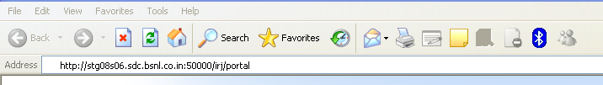

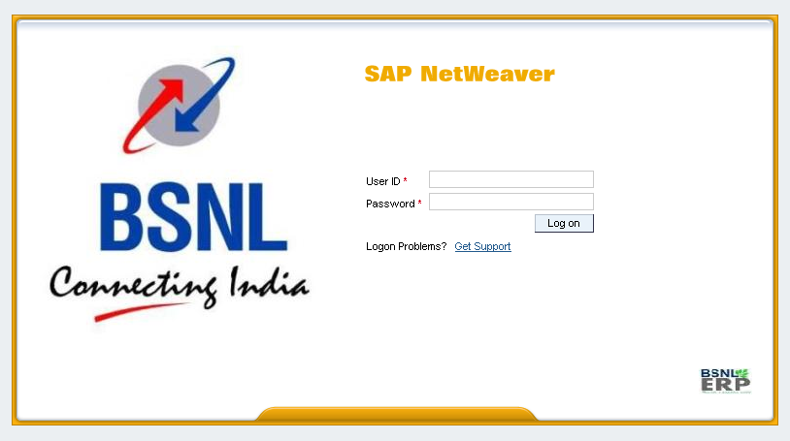

On Screen SAP Net Weaver, enter information in the fields as specified in the table below:

Field Name | Description | User Action and Values
User | User ID | Enter a valid user id.
Password | Password for User ID | Enter a valid user password.

Click on button or Press Enter key.

Understanding elements of SAP EP (Portal Desktop)

The portal desktop refers to the entire portal screen, including all displayed content and its layout.

User Name

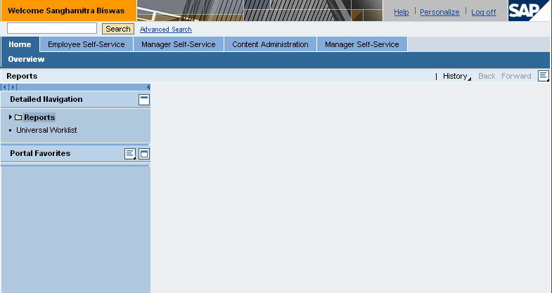
Search
Home Page
Help

Navigating Menus

On the home page screen of SAP Employee Self Services, click on Employee Self-Service tab in order to access certain service (For example, Employee Self Services → Employee Search→ Working time→ Personal Information → Personal Data).

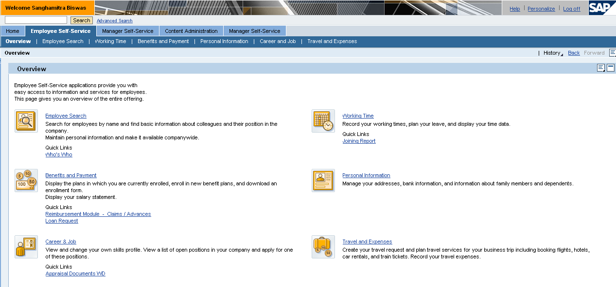
Log Off

Logging out of SAP EP System

On screen SAP Employee Self Services, click on Log off to log out of SAP EP system.

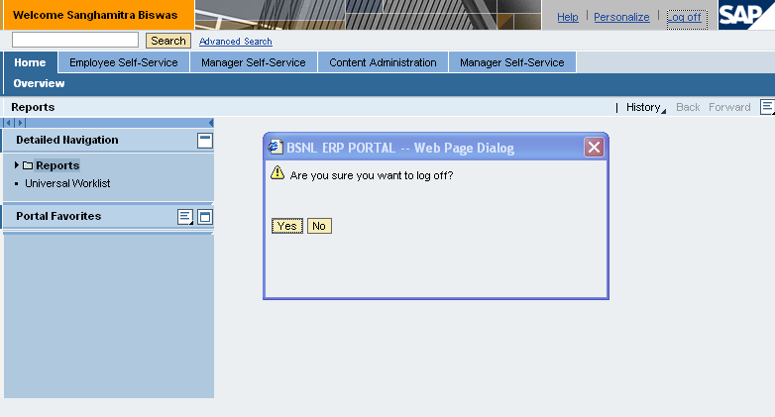
Log Off

Scenario: Employee Search

Introduction

This scenario describes the processes where employees are allowed to search their colleagues , create or display or change their Departmental information (Building and Room Number), Communication information (Extension number and Email ID).Type of information that are opened for employees’ update and viewing are as below:

- Who’s Who
- Change Own Data

Scenario Diagram

Who’s Who
Advance Search

Employee Self Service
Employee Search

Change Own Data

Who’s Who
Search for employees by name and find basic information about colleagues and their position in the company. Information about colleagues can be seen by just entering First or Last Name or both in the search area.

Path | Employee Self Services > Employee Search > Who’s Who
Purpose | Employee can search colleagues.

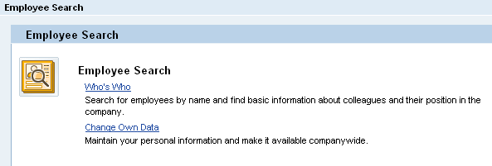

Step 1:
Now you select the Who’s Who option to search for colleges and basic information about them.

Step 2:
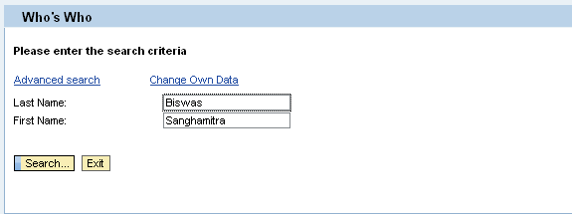

Enter either Last Name or First Name or both in the prescribed columns and then press Search option.

Step 3:
There is one more option of Advanced Search, using which a number of search criteria can be mentioned to make the search narrower.

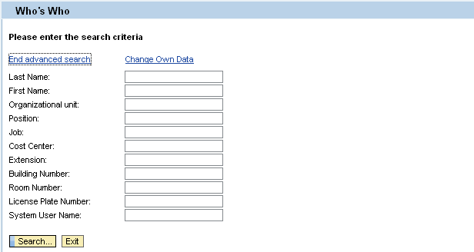

The system will show you all the employee numbers that match these criteria.

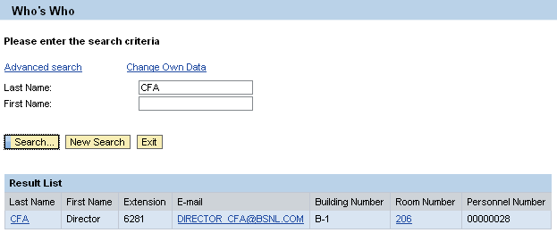

You can click on CFA to see more information about this employee.

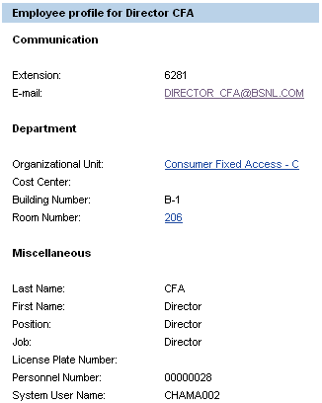

Change own data
Maintain your personal information and make it available companywide. Employees can create, display and change their Departmental information (Building and Room umber) and Communication information (Extension number and Email ID).

Path | Employee Self Services > Employee Search > Change own Data
Purpose | Employee can change own data.

Step 1:
Click on ‘Change own data’ option either to overview or edit your own data using the options in the screen shown below.

Step 2:
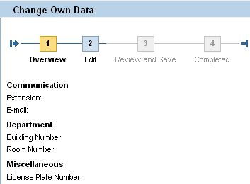

Selected the edit option to change your data then the following screen will open up.
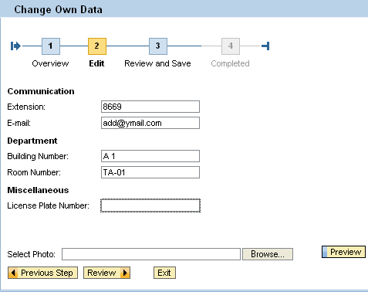
Here you can edit your communication, Department and Miscellaneous information.Photo can also be uploaded from this place.
Step 3:
Click on Review to view the changes made by you or else can directly click on Review and Save to view and save the changes being made.If you select Review following screen will appear.
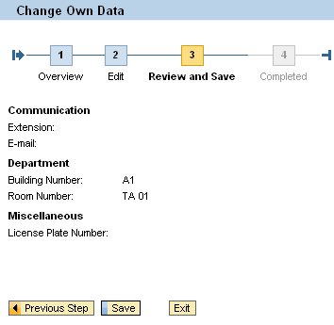
If required can go back to the previous step by clicking on or else can click on to store the changes. If you click on save following screen will appear.

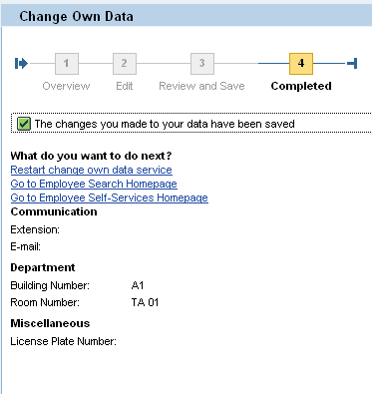

Step 4:

Now you can ether Restart change own data service
Or
Go to Employee Search Homepage
Or
Go to Employee Self-Services Homepage

Scenario: Personal Information

Introduction
This scenario describes the processes where employees are allowed to maintain or view their personal information at their own time. Type of information that are opened for employees’ update and viewing are as below:

- Addresses
- Bank Information
- Family Member / Dependent (applicable to Spouse, New child only)
- Personal Data (Update Marital Status and View First name, Last name, Date of Birth, Nationality, Gender etc.)

Scenario Diagram
Addresses

Permanent Residence
Emergency address
Mailing address

Bank Information

Main Bank

Travel Expenses
Employee Self Service
Personal Information

Family Member / Dependent
New Spouse
New Child

Personal Data

Immovable Property Returns

Address
This is an overview of Address screen showing the current record(s) (if any) maintained.
Employee can choose to edit the existing address or add new addresses.
The following 3 Address Types will be open up for employees’ update:
    - Permanent Residence
    - New Emergency Address
    - New Mailing Address

Access transaction by:

Path | Employee Self Services > Personal Information > Address
Purpose | Employee can create new address or update his existing address (e.g. Permanent)

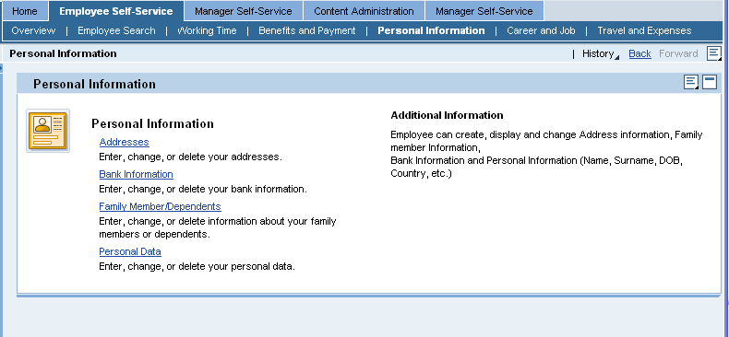

Step 1:
On the Personal Information Overview page, click on the Address link. Subsequently, the below screen appears with Address overview.
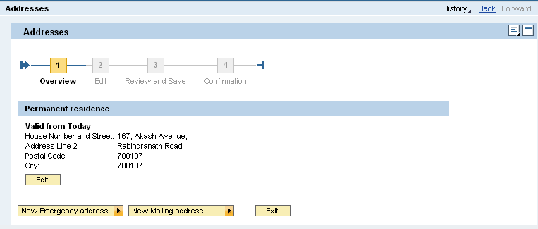

System allows the user to maintaining the following types of address.
- Permanent/Local Residence Address
- Mailing Address
- Emergency Address

Click on Edit to change the current Permanent address
(Or)
Click on New Emergency Address to create a new emergency address
(Or)

Click on New Mailing Address to create a new mailing address

Step 2:
On screen Address, enter your address in the fields as specified in the table below:

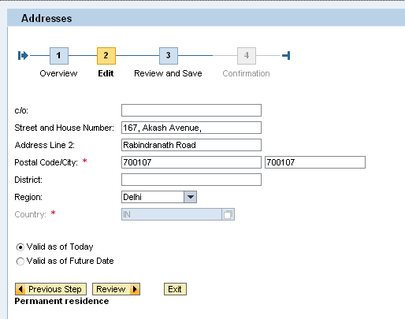

No | SAP Fields | Field Descriptions
1 | C/O | Write C/O Name.
2 | Street and House number | Write your street and house number
3 | Address line 2 | Write your Address line 2
4 | Postal Code/ City | Write your Postal Code/ City
5 | District | Write your District name.
6 | Region | Write your State name
7 | Country | Write India
8 | Validity as of Today (or)  Valid as of future date | Validity date of the Address.  Enter the date if the option is “Valid as of future date”

Click on Review to proceed with the editing.

Step 3:
Review the details as per the screen.
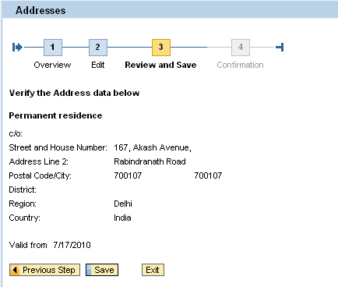

Click on Save to proceed with saving the Address.

Step 4:

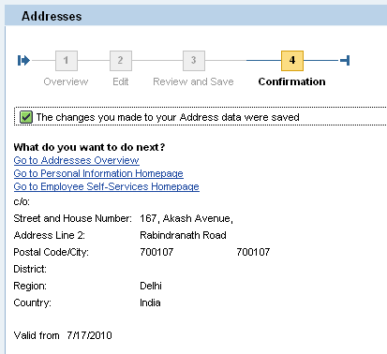

Message will be shown as in Status bar on Successful saving of the address details.
Click on Go to Address Overview to go back to the Address Overview screen.
(Or)
Click on Go to Personal Information Homepage to go back to the Personal Information Overview screen.
(Or)

Click on Go to Employee Self Services Homepage to go back to the Employee Self Services Overview screen.

Bank Information
Employees can use this service to display and edit their own bank information. This means that they can continually update their data, thereby relieve the HR department of time-consuming, cost-intensive activities.
Employees’ bank details are used for bank transfers from payroll and to reimburse travel expenses.

In the Overview, employees can display an overview of their current bank data.

Access transaction by:
Path | Employee Self Services > Personal Information > Bank Information
Purpose | Employee to update the current bank information (i.e. bank name, bank key and account number) maintained.

Step 1:

On the Personal Information Overview page, click on the Bank Information link. Subsequently, the below screen appears with Bank Details overview.

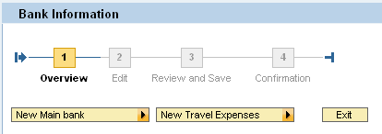
Click on overview 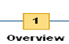 to view the current Bank Details.

Step 2:
Selected the New Main Bank option to edit your bank details. The following screen will open up. Enter information in the fields as specified in the table below:

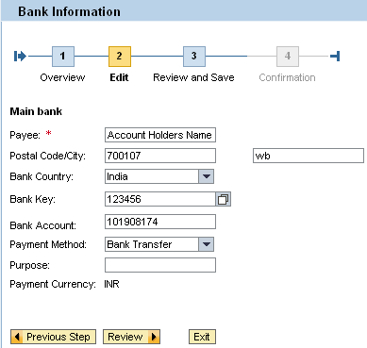

Here you can edit your details relating to your New Main Bank, wherein you can fill Account Holders Name, Address, Bank Account Name, Bank Key (would be provided separately). We have selected Bank Transfer as payment method but employees are available with other methods like bank transfer, cash payment, cheque, ECS, Money order, Others.

No | SAP Fields | Field Descriptions
1 | Payee | Write account Holder name
2 | Postal Code/City | Write City name and Postal code of the Employees address.
3 | Bank Country | Write the country name where Bank is located
4 | Bank Key | Write Bank Key
5 | Bank Account | Write Bank Account number
6 | Payment Method | Select any one payment method from the drop-down list.
7 | Purpose

Step 3:
Click on Review to view the changes made by you or else can directly click on Save to view and save the changes being made.
If you select Review following screen will appear
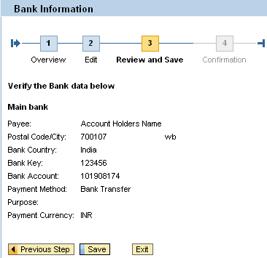
If required can go back to the previous step by clicking on.
Click on to store the changes.
Following screen will appear.
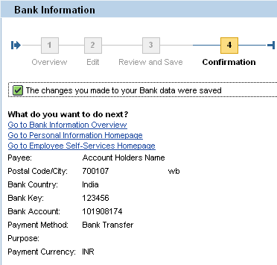

Message will be shown as in Status bar on Successful saving of the Bank details.
Step 4:
Now you can either Go to Bank Information overview or can Go to Personal Information Homepage or else can Go to Employee Self-Services Homepage.
Click on Go to Bank Information Overview to go back to the Bank Information Overview screen.
(Or)

Click on Go to Personal Information Homepage to go back to the Personal Information Overview screen.
(Or)

Click on Go to Employee Self Services Homepage to go back to the Employee Self Services Overview screen.

Family Member /Dependents

Employees can use this service to display and edit data about their family members and dependents. This means that they can continually update their data, thereby relieve the HR department of time-consuming, cost-intensive activities.

The Family Member /Dependents service contains input screens for Spouse and Children details. In the Overview, employees can display an overview of their current data about dependents and Family Members.

Access transaction by:
Path | Employee Self Services > Personal Information > Family Member/Dependents
Purpose | Employee can maintain family members and dependents records.

Step 1:
On the Personal Information Overview page, click on the Family Members/Dependents link. Subsequently, the below screen appears.

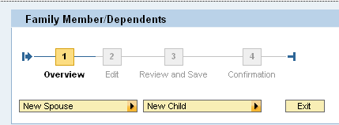

System allows the user to maintaining the following types of Family Type details.
- Spouse
- Child

Click on New Spouse to create a new Spouse details
(Or)
Click on New Child to create a new child details

Step 2:
On screen Family Member/Dependents, enter information in the fields as specified in the table below:

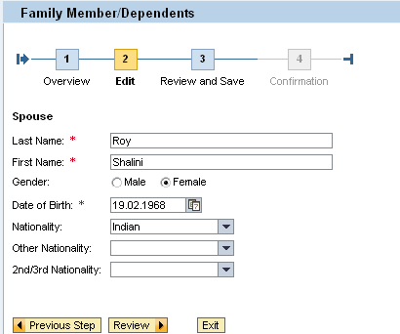

No | SAP Fields | Field Descriptions
1 | Last Name | Write Spouse last name
2 | First Name | Write Spouse First name
3 | Gender | Specify gender
4 | Date of Birth | Write Spouse DOB
5 | Nationality | Write nationality of Spouse
6 | Other Nationality
7 | 2nd/3rd Nationality

Click on Review to proceed with the editing.

Step 3:
Review the details as per the screen.
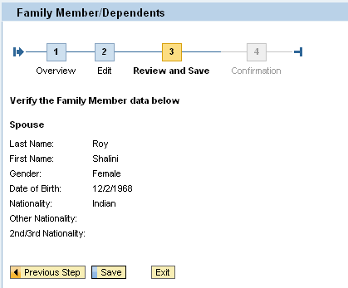

Click on Save to proceed with the saving the Family member details.

Step 4:

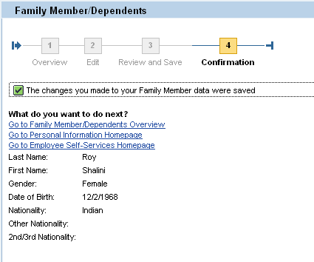

Message will be shown as in Status bar on Successful saving of the Family Member details.

Click on Go to Family Member/Dependents overview to go back to the Family Member Overview screen.
(Or)
Click on Go to Personal Information Homepage to go back to the Personal Information Overview screen.
(Or)
Click on Go to Employee Self Services Homepage to go back to the Employee Self Services Overview screen

Personal Data
Employee can create, display and change Address information, Family member Information, Bank Information and Personal Information (Name, Surname, DOB, Country, etc.)
In the Overview, employees can display an overview of their current personal data. In the input screen, they can make the changes.

Access transaction by:
Path | Employee Self Services > Personal Information > Personal Data
Purpose | Employee can update their personal data.

Step 1:

On the Personal Information Overview page, click on the Personal Data link. Subsequently, the below screen appears with Personal Data overview.
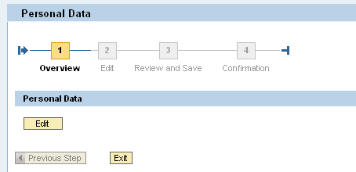

Click on Edit to change the current Personal Details.

Step 2:

On screen Personal Data, enter information in the fields as specified in the table below:

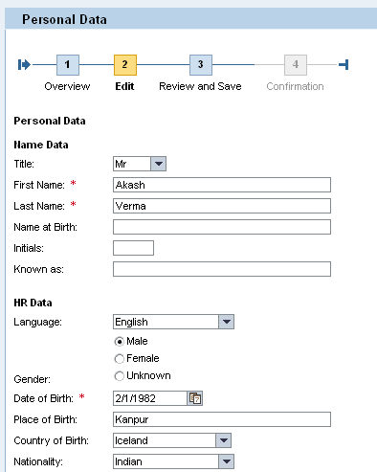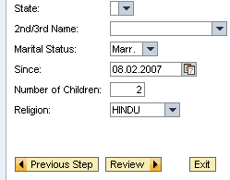

No | SAP Fields | Field Descriptions
1 | Title | Specify the title by selecting Mr., Mss, Ms, Mrs
2 | First Name | Write your First name
3 | Last Name | Write your last name
4 | Name at birth
5 | Initials | Write initials
6 | Known As
7 | Language | Write English
8 | Gender | Write your gender
9 | Date of Birth | Write your Date of Birth
10 | Place of Birth | Mention your place of Birth
11 | Country of Birth | Select your birth country’s name from the drop-down list
12 | Nationality | Write your nationality
13 | State
14 | 2nd/3rd Name
15 | Marital status | Marital Status (Single, Marr’d, Widow, Divor)
16 | Since | Write your marriage date
17 | No. of Children | Mention number of children you have
18 | Religion | Write your religion name

Click on Review to proceed with the editing.

Step 3:
Review the details as per the screen.
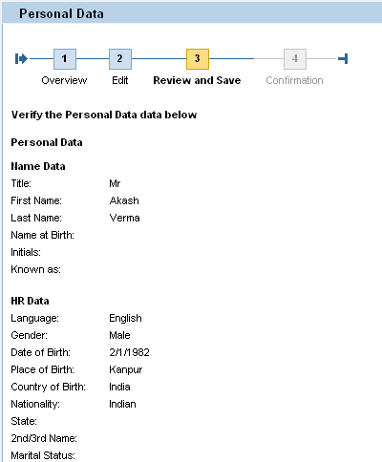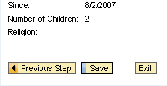

Click on Save to proceed with the saving the Personal Data.

Step 4:

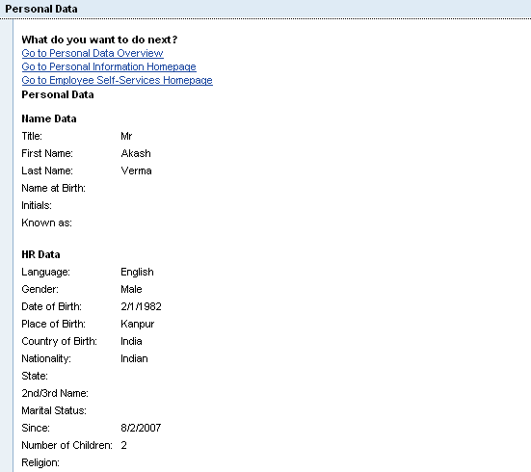

Click on Save to proceed with the saving the Personal Data.

Click on Go to Personal Data Overview to go back to the Personal Data Overview screen.
(Or)
Click on Go to Personal Information Homepage to go back to the Personal Information Overview screen.
(Or)
Click on Go to Employee Self Services Homepage to go back to the Employee Self Services Overview screen

Immovable Property Returns

Employee can maintaining the details of their own immovable property and can update the same annually. Employee will file the annual property returns on the ESS, which will be further updated in the form of the infotype and corresponding subtypes.

Access transaction by:
Path | Employee Self Services > Personal Information > Immovable Property Returns.
Purpose | Employee can submit the statement of immovable property.

Step 1:
Click on the ‘Personal Information’ option a new screen will open with five options shown below.
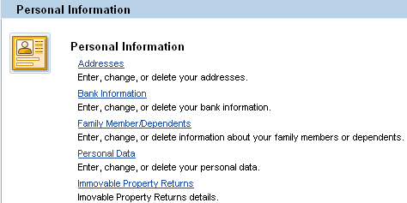

Step 2:
Click on the ‘Immovable Property Return’ option either to overview or edit your own data using the options in the screen shown below.
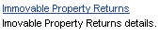

Step 3:

To change or enter status of your Immovable Property for filling IPR return select the option from the drop-down menu from the screen shown below.
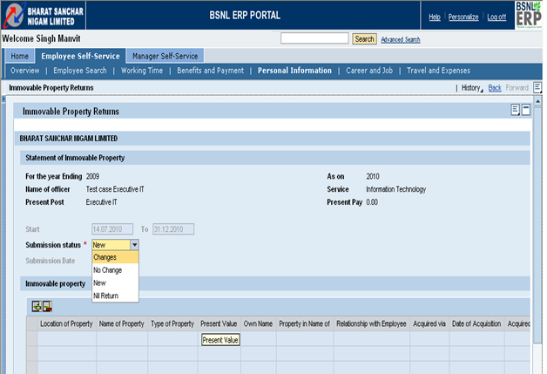

Step 4:
Select the required option from the four options shown above according to your requirement say if you want to change your return data select the Change option it will help you to edit your already stored data , to enter new data select the New option and fill in the required details , if there is no change in data for filling return then select the No change option shown above and if you don’t have immovable property for the assessment year you have to select the Nil Return option.

Step 5:
Here after selecting the required options you need to select the submit button followed by the save option shown in the end of the below process.

Step 6:
Process to Enter New Immovable Property for the current assessment year.
Select the appropriate option from the drop down menu shown above.Here we have selected New option to fill in the required details shown below.
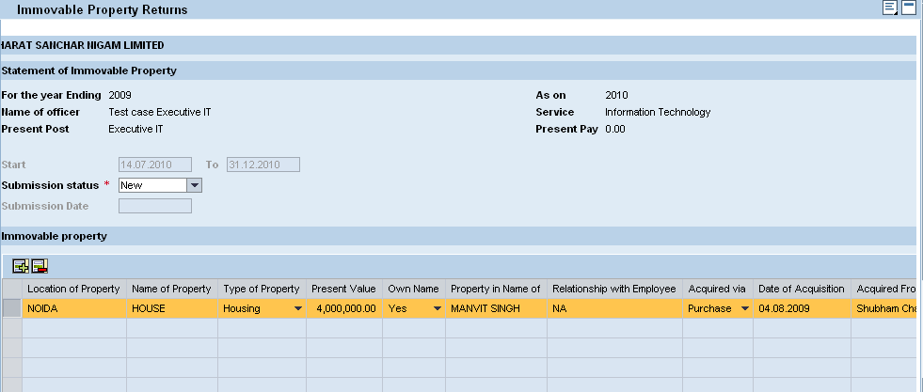

Click the add box shown and fill the required details and click on the Submit box .
No | SAP Fields | Field Descriptions
1 | Location of the Property | Specify the location name where the property is located.
2 | Name of the property | Write the property name. For example Flat, House, Land etc.
3 | Type of Property | Write your last name
4 | Present Value | Present value of the property in rupees.
5 | Own Name | Specify whether the property is in your own name or not.
6 | Property in the name of | If the property is not in your own name then write the property owner’s name.
7 | Relationship with the employee | Mention the relationship type with the property holder.
8 | Acquired via | Select the matching option from the drop-down list.
9 | Date of Acquisition | Write the date when you have acquired the property.
10 | Acquired from | Mention from where you have acquired the property.
11 | Purchase Approval Order No. | Write the purchase order number.
12 | Annual income of Property | Write the annual income from the property. If the income from the property is nil then this field is not required.
13 | Remarks | Any other information related to the property.

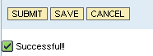
Click on the save box to finish the process and do the final submission.

Scenario: Working Time

Introduction
Leave Request enables employees to quickly and clearly enter and submit leave request or other types of leaves. Address of the employee during leave can also be stored. Company holiday calendar is attached for reference. Leave Balances can be checked from Quota overview.

Time related transactions are as follows:
- Leave Request
- Leave Overview
- Joining Report

Short Description | Full Explanation | Role
Leave Request | Employee can create and submit a new Leave Request. | Employee
Quota Overview | For leave planning purposes, employee can view his/her leave balance and entitlement via Leave Quota Overview. All leave types with entitlement will be listed for employee’s viewing. | Employee
Joining Reports | Joining Back Form Leave Form. Here start date and end date of the leave can be seen.  Joining date after the leave period can also be seen. | Employee

Leave Request

Employee Self Service
Working Time
Quota Overview
Time account
Joining Reports

Access transaction by:
Path | Employee Self Services > Working Time > Leave Request
Purpose | Employee can crate and submit a new Leave Request or he/she can change/cancel/delete the existing requests.

Leave Request

This function enables you to control the processing of leave requests and other absences. The function comprises the entire leave request process. The process starts with the creation of a leave request and the processing of it before it is finally posted to the backend system.

The Leave Request function comprises the following areas:
- Creation of leave request by employee
- Forwarding of request to manager for approval
- Controlling of deletion and cancellation processes
- Status tracking and monitoring
- Posting of absences to the backend system

Employees can use the Leave Request service to request both absences (infotype 2001) and attendances (infotype 2002). This means that you can also process records of the Attendances infotype (2002) that have the quality of an absence in your company, such as training courses.

Types of leave in BSNL are as follows:-

Sl No | Leave Type
1 | Childcare Leave
2 | Commuted Leave
3 | Diesnon W/o Brk in Serv.
4 | Diesnon With Brk in Serv.
5 | Earned Leave
6 | Extraordinary Leave
7 | Extraord. Lv With Med Cer
8 | Hospital Leave
9 | Half Pay Leave
10 | Half Pay Leave
11 | Joining time Leave
12 | Leave Not Due
13 | Leave Without Pay
14 | Maternity Leave
15 | Non Pay Absence
16 | Paternity Leave
17 | Restricted Holiday
18 | Special Casual Leave
19 | Special Disability Leave
20 | Study Leave
21 | Absence due to Strike
22 | Transfer leav without Pay

Step 1:

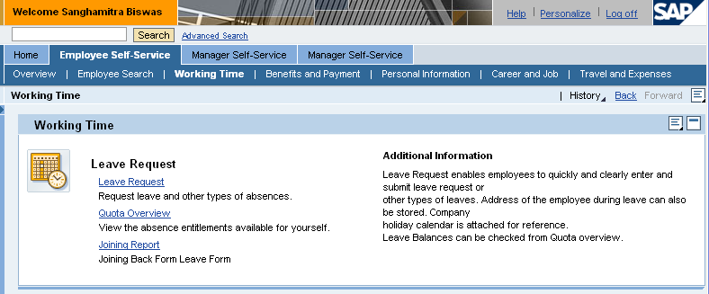

On the Working Time Overview page, click on the Leave Request link. Subsequently, the below screen appears with Leave Request.

Step 2:

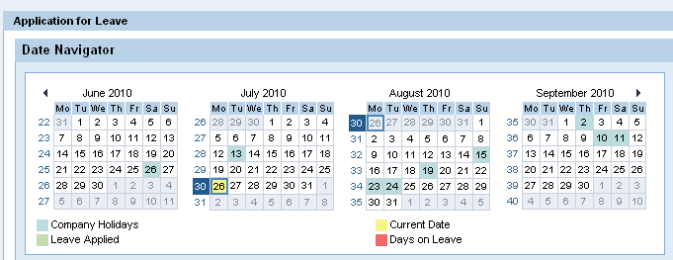
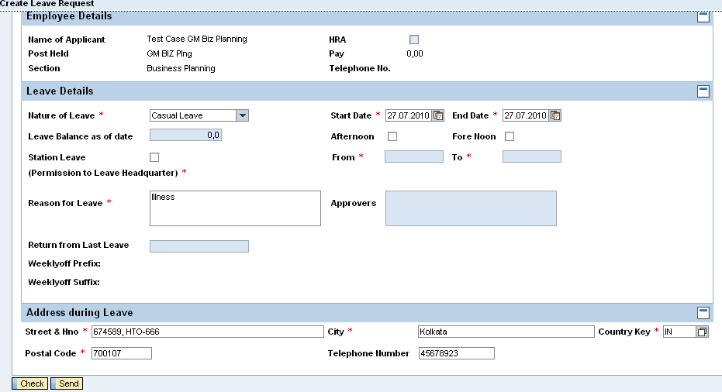
Short Description | Full Explanation | Role
Nature of Leave | Select the appropriate type of leave availed from the drop down. | Employee
Start Date, End Date | Enter the period for which leave is to be availed. | Employee
Station Leave | Check this if the employee is seeking permission to leave station, and then enter the corresponding “From”, “To” period | Employee
Reason for Leave | Enter the reason why the leave is to be taken | Employee
Address During Leave | Please enter the correspondence address for the period on leave | Employee

Step 3:
Click On Send to Submit 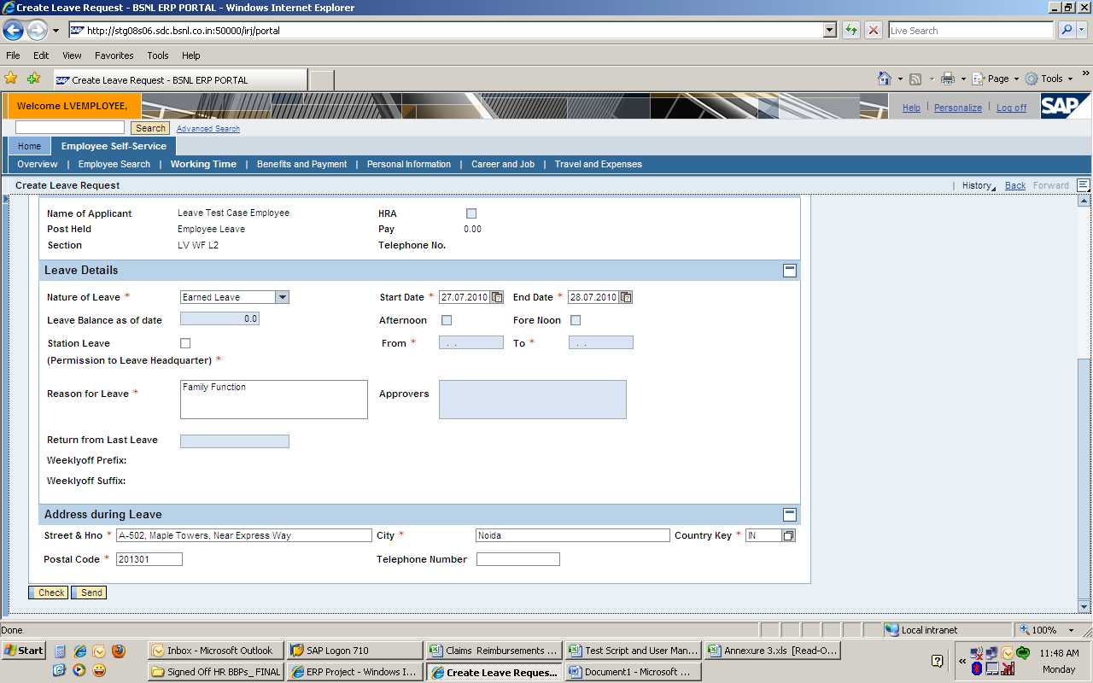

The following message will appear confirming that the Leave Request has been successfully saved.

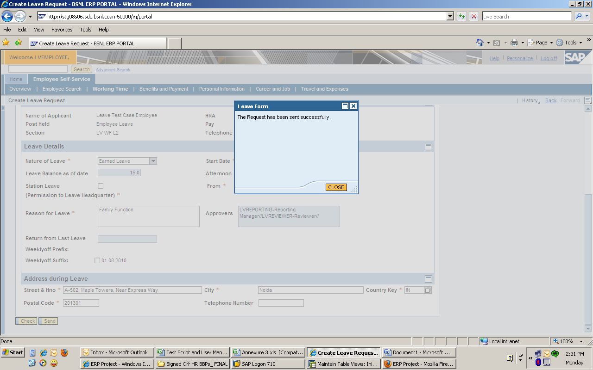

Leave Request service provide the following sub services
- Show/Hide Team Calendar : Shows the Team’s calendar with Leave Details
- Show/Hide Calendar : 3 months calendar
- Show/Hide Time Accounts : Leave Quota Overview
- Show/Hide Overview of Leave : Leave Overviews with status

Quota Overview

Leave Balances can be checked from Quota overview.

Access transaction by:
Path | Employee Self Services > Working Time > Quota Overview
Purpose | Employee can view the absence entitlements available by own.

Step 1:

On the Working Time Overview page, click on the Quota Overview link. Subsequently, the below screen appears with Quota Overview screen.

Step 2:

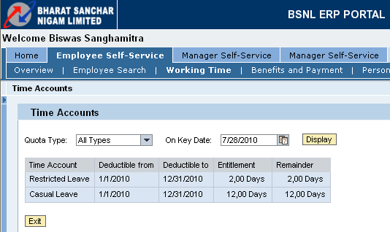
Click on Exit , to go back to the Working Time home page.

Joining Reports

This is a report which contains information on Leave details. This report contains Joining date, Start date of the leave, End date of the leave and Medical Certificates.

Access transaction by:
Step 1:
Path | Employee Self Services > Working Time > Joining Reports
Purpose | Joining Back from Leave details

On the Working Time Overview page, click on the Joining Report link. Subsequently, the below screen appears.

Step 2:

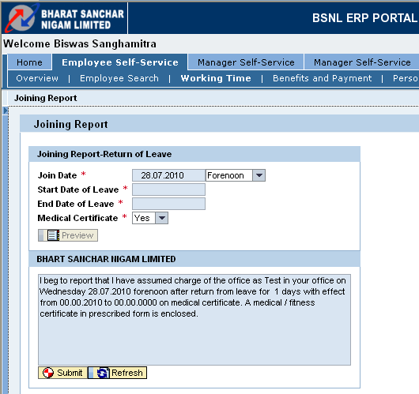

Step 3:
Click on button.
A window with the message mail has been sent successfully would appear.

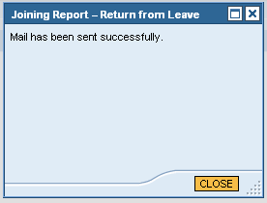

Click on button, it will take you to the Working Time homepage.

Scenario: Career and Jobs

Introduction
Employees are allowed to enter their own skills in ESS. Managers can utilize the database to identify employee with the appropriate skills for the internal use of the company and for training.By the Appraisal Documents tabs employee can display the appraisal that were made of his/her work. This helps to reduce the administrative load on the human resources department and Managers. Encourages participation and responsibility by the individual emoployee.

Career and Jobs related transactions are as follows:
- Skills
- Appraisal Documents

Edit Skills
Skills
Add New Skills
Delete Skills
Employee Self Service
Career and Jobs
Appraisal Documents

Path | Employee Self Services > Career and Jobs > Skills
Purpose | Employee can view the skills catalog and create or change own skills profile

Step 1:

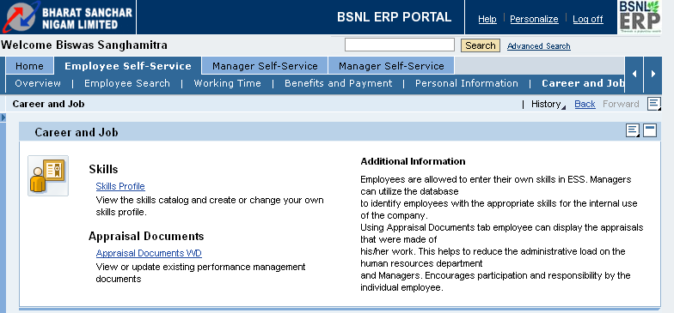
Click on Skills Profile link.

Step 2:
Following screen will appear. In this screen employee qualifications and its proficiency level could be seen.
ESS supports end user to edit the existing skills or he/she can delete the existing information and add new skills.
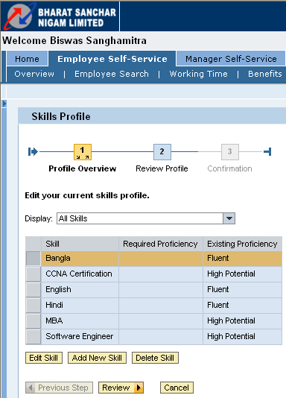
Click here to edit the existing skills
Click here to add new skills
Click here to delete skills

Step 3:
Click on the skills that you want to edit and then press button

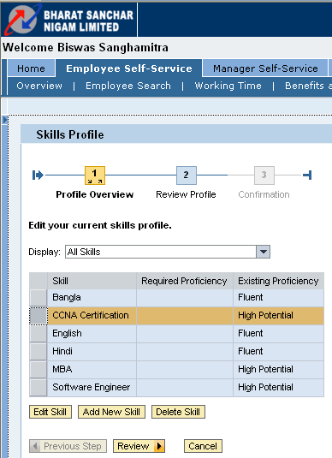

Step 4:

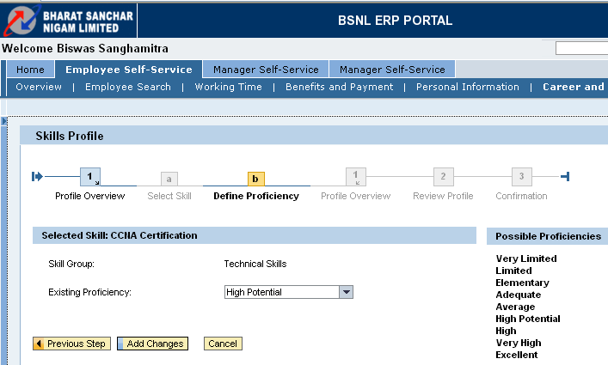
Click on . You will get a drop down list. Choose the proficiency level as per your choice and then click on add changes. Portal will save the changes.
After that you can go to previous step , select other skills and repeat step- 4
(Or)
Click on Cancel to cancel the changes being made.
Step 5:
Through below screen you can add new skills to the employee profile.

Skills Catalog
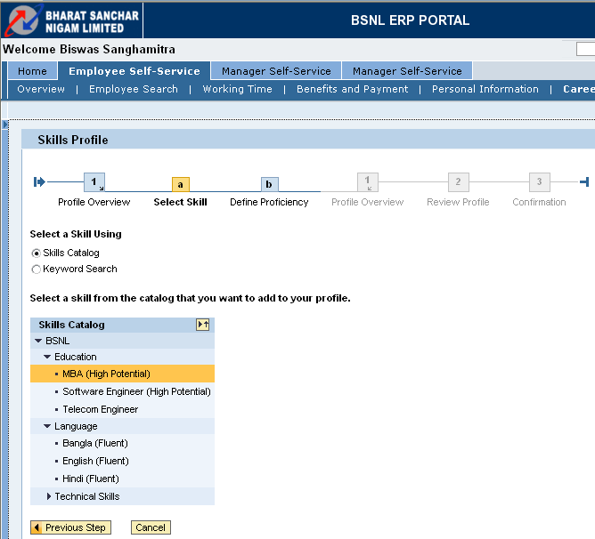
Click on the skill that you would like to add
Click on the radio button skills catalog to select the skill from the skills catalog or else click on Keyword search where you can write the skill that you want to change.

Step 6:

Keyword Search
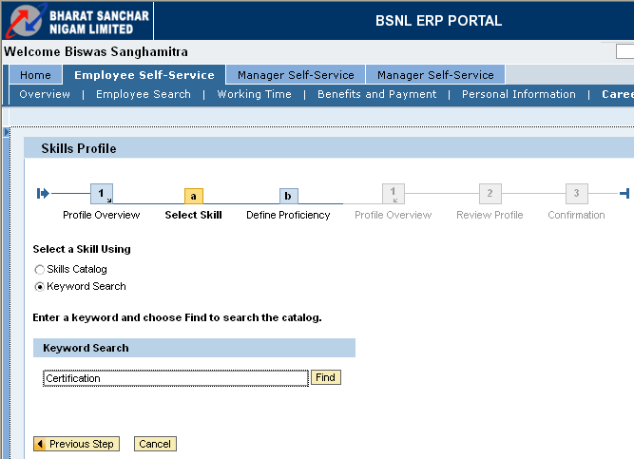

Write the Skill name and click on find

Step 7:

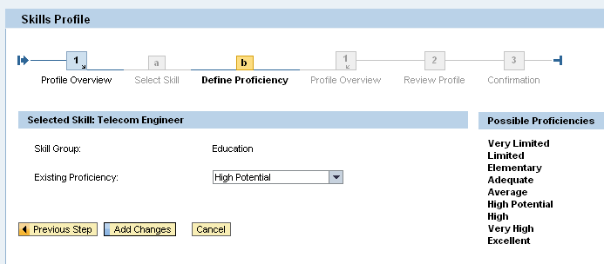
The skills that you have selected to add will appear and from the field Existing Proficiency , proficiency level can be maintained. Select the matching proficiency level from the drop-down list and click on add changes

Step 8:
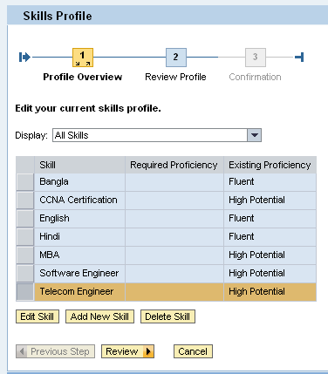
Click on review

Step 9:
You can check that new skill got added into the list.

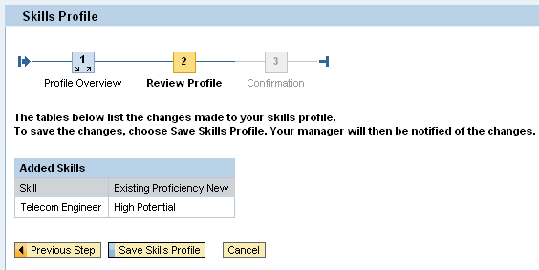
Click on the save skills profile, to save the changes.
(Or)
To go back to the previous page click on tab.
(Or)
Click on Cancel

Step 10:
Skills profile is saved can be confirmed by the message following message:-
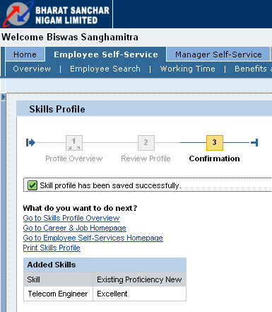

Click on Go to Skills Profile Overview to go back to the Skills Profile Overview screen.
(Or)
Click on Go to Career & Job Homepage to go back to the Career & Job homepage screen.
(Or)
Click on Go to Employee Self Services Homepage to go back to the Employee Self Services Overview screen.
(Or)
Click on Print Skills Profile to take the print out of the Skills Profile.

Scenario: Travel and Expenses

Introduction

Employee can efficiently and reliably carry out all the process concerned with business
trips, from Travel request to Travel Planning right up to submitting Travel Expenses.

Travel and Expenses related transactions are as follows:

- My Trip and expenses
- My Employees
- Create Travel Request
- My Travel Profile
- Unlock Personnel number

Overview
My trip and expenses
My Employee
Employee Self Service
Travel and Expenses
Create New

Create Travel Request

Personal Information
My Travel Profile

Unlock Personal Number

My Trip and Expenses

Path | Employee Self Services > Travel and Expenses > My Trip and Expenses and Create Travel Request
Purpose | Display, change, copy, or cancel one of your existing travel plans, requests or expense reports.

Step -1

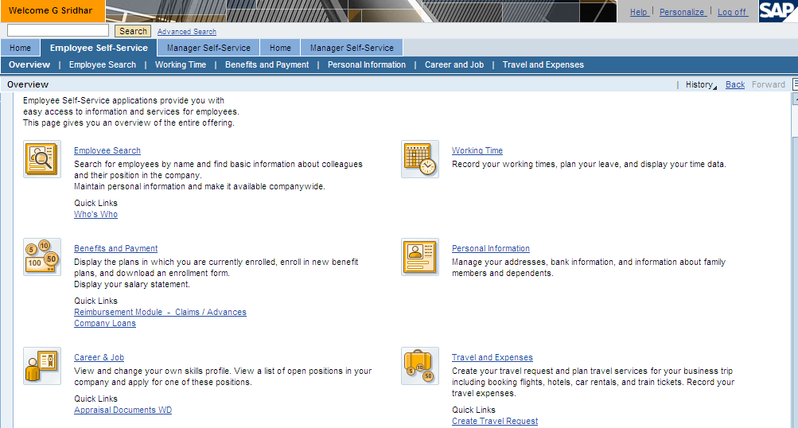
Click on Travel and Expenses 

Step -2

The below Home Screen of the link Travel and Expenses will appear where you have to create your new Travel Request:

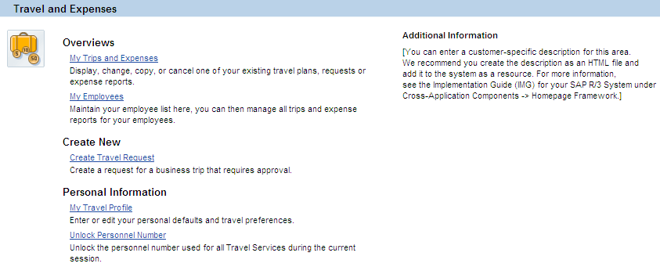

Click on link to settle a travel request for which travel has happened.

Step -3
The following screen appears.

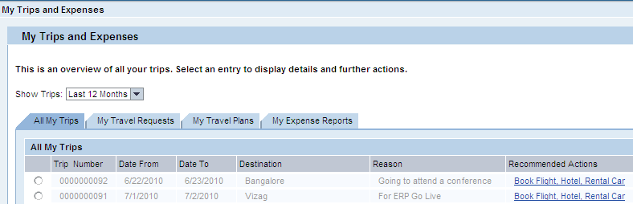

Go to Tab for

Step -4
The following screen appears:

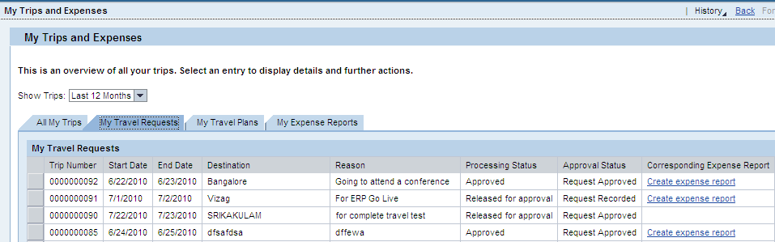
Click on link

Step -5

The following screen appears:
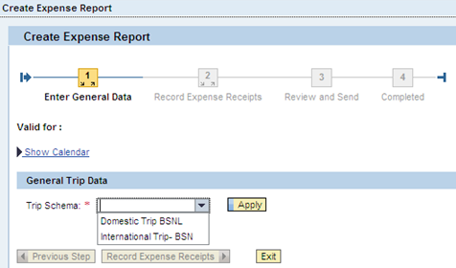

Select Trip Schema from the drop down and click on.

Step -6
The following screen appears:

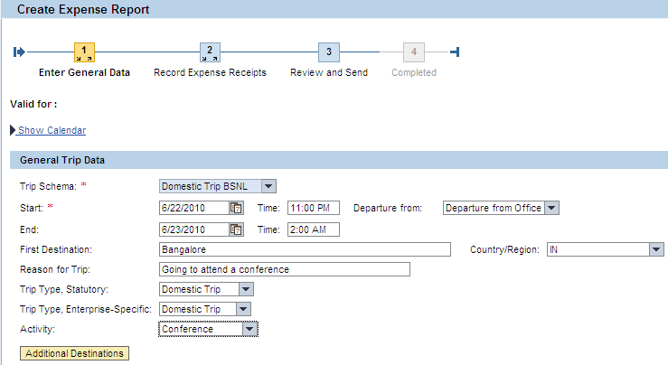
Select the relevant option for the below from the drop down listed

Option | Drop-Down Values
Trip Type, Statutory | - Domestic  - International
Trip Type,  Enterprise- Specific | - Domestic  - International
Activity | - Conference  - Inspection  - Meeting  - Others  - Sales & Marketing  - Seminar  - Sports Event  - Training  - Union Event

Step -7

Click on at the bottom of the page

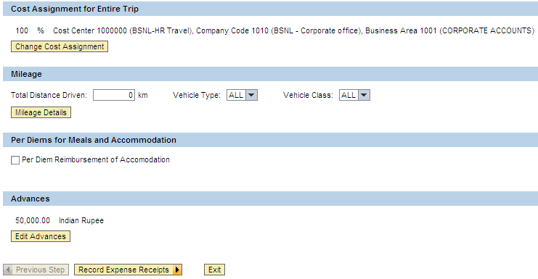

Step -8

On clicking on the below screen will appear

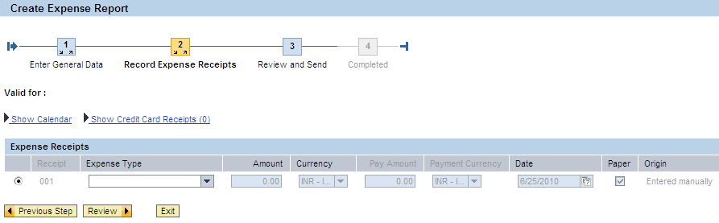

Select an expense type from the drop down list maintained.

Step -9

On selecting the expense type the below screen appears where u need to fill all fields marked with a start *
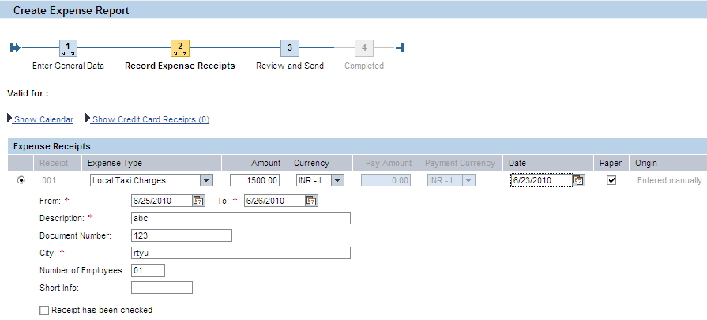

Click on

Step -10
The following screen appears:
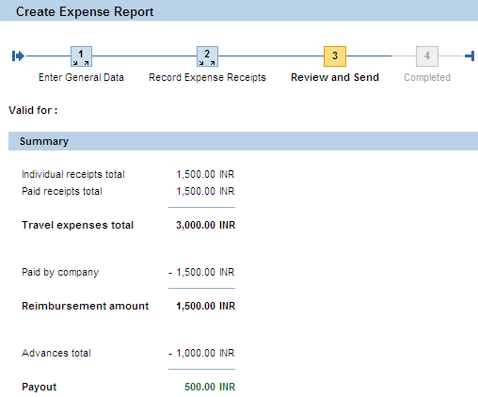

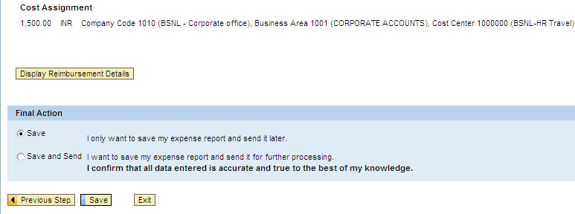

Click on.

Step -11

Finally the below screen appears confirmation that the Expense Report has been created:

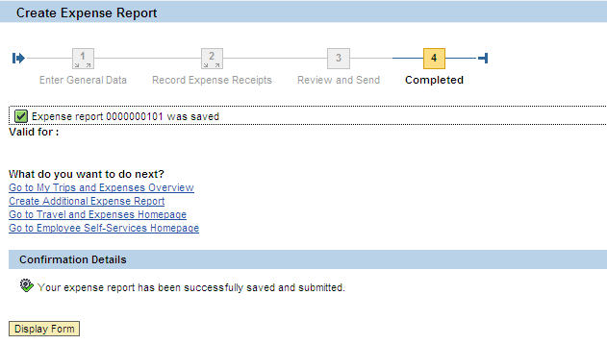

An expense report number is generated:

When the link is clicked the report form is displaced in PDF format.

